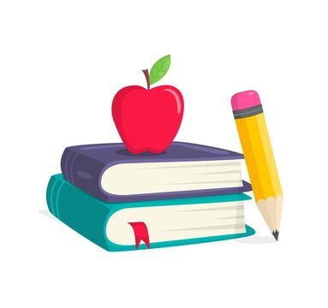
Kindergarten Class Supplies for 2026-27
- 2 pack of Crayola Crayons (24 count)
- 3 pack Crayola Markers (16 Count)
- 2 pack Crayola Colored Pencils (24 count) (non-erasable)
- 1 coloring book - child’s choice
- (1) 3 pack Elmer’s Jumbo glue sticks (purple glue) (0.77 oz)
- 2 plastic pocket folders - SOLID COLORS ONLY (NO DESIGNS?NO BRADS)
- 1 Pink Pearl Large Eraser (rectangular)
- BOYS ONLY
  - 1-2 Large Roll of Bounty Paper Towels
  - 1 box of Ziploc Sandwich Bags
  - 1 pack of white cardstock
- GIRLS ONLY
  - 1-2 Large Roll of Bounty Paper Towels
  - 1 box of Ziploc Sandwich Bags
  - 1 pack Colored Cardstock
- 2 large containers of Colorx wipes (one for cafeteria)
- 2 boxes of Kleenex
- 4 reams of copy paper
- Headphones (no earbuds)
- Nap Mat (sheet mat with attached top sheet) (should be padded and cushioned)
- Backpack (no wheels) Should be large enough to fit a standard sized folder and lunch box inside
- Water Bottle (brought to and from school every day)
- Please only write your child’s name on their Coloring Book, Backpack, Nap Mat, Lunch Box, Sweatshirt, and Water Bottle. All other items will be shared and do not need to be labeled. It’s going to be a GREAT year in Kindergarten!

