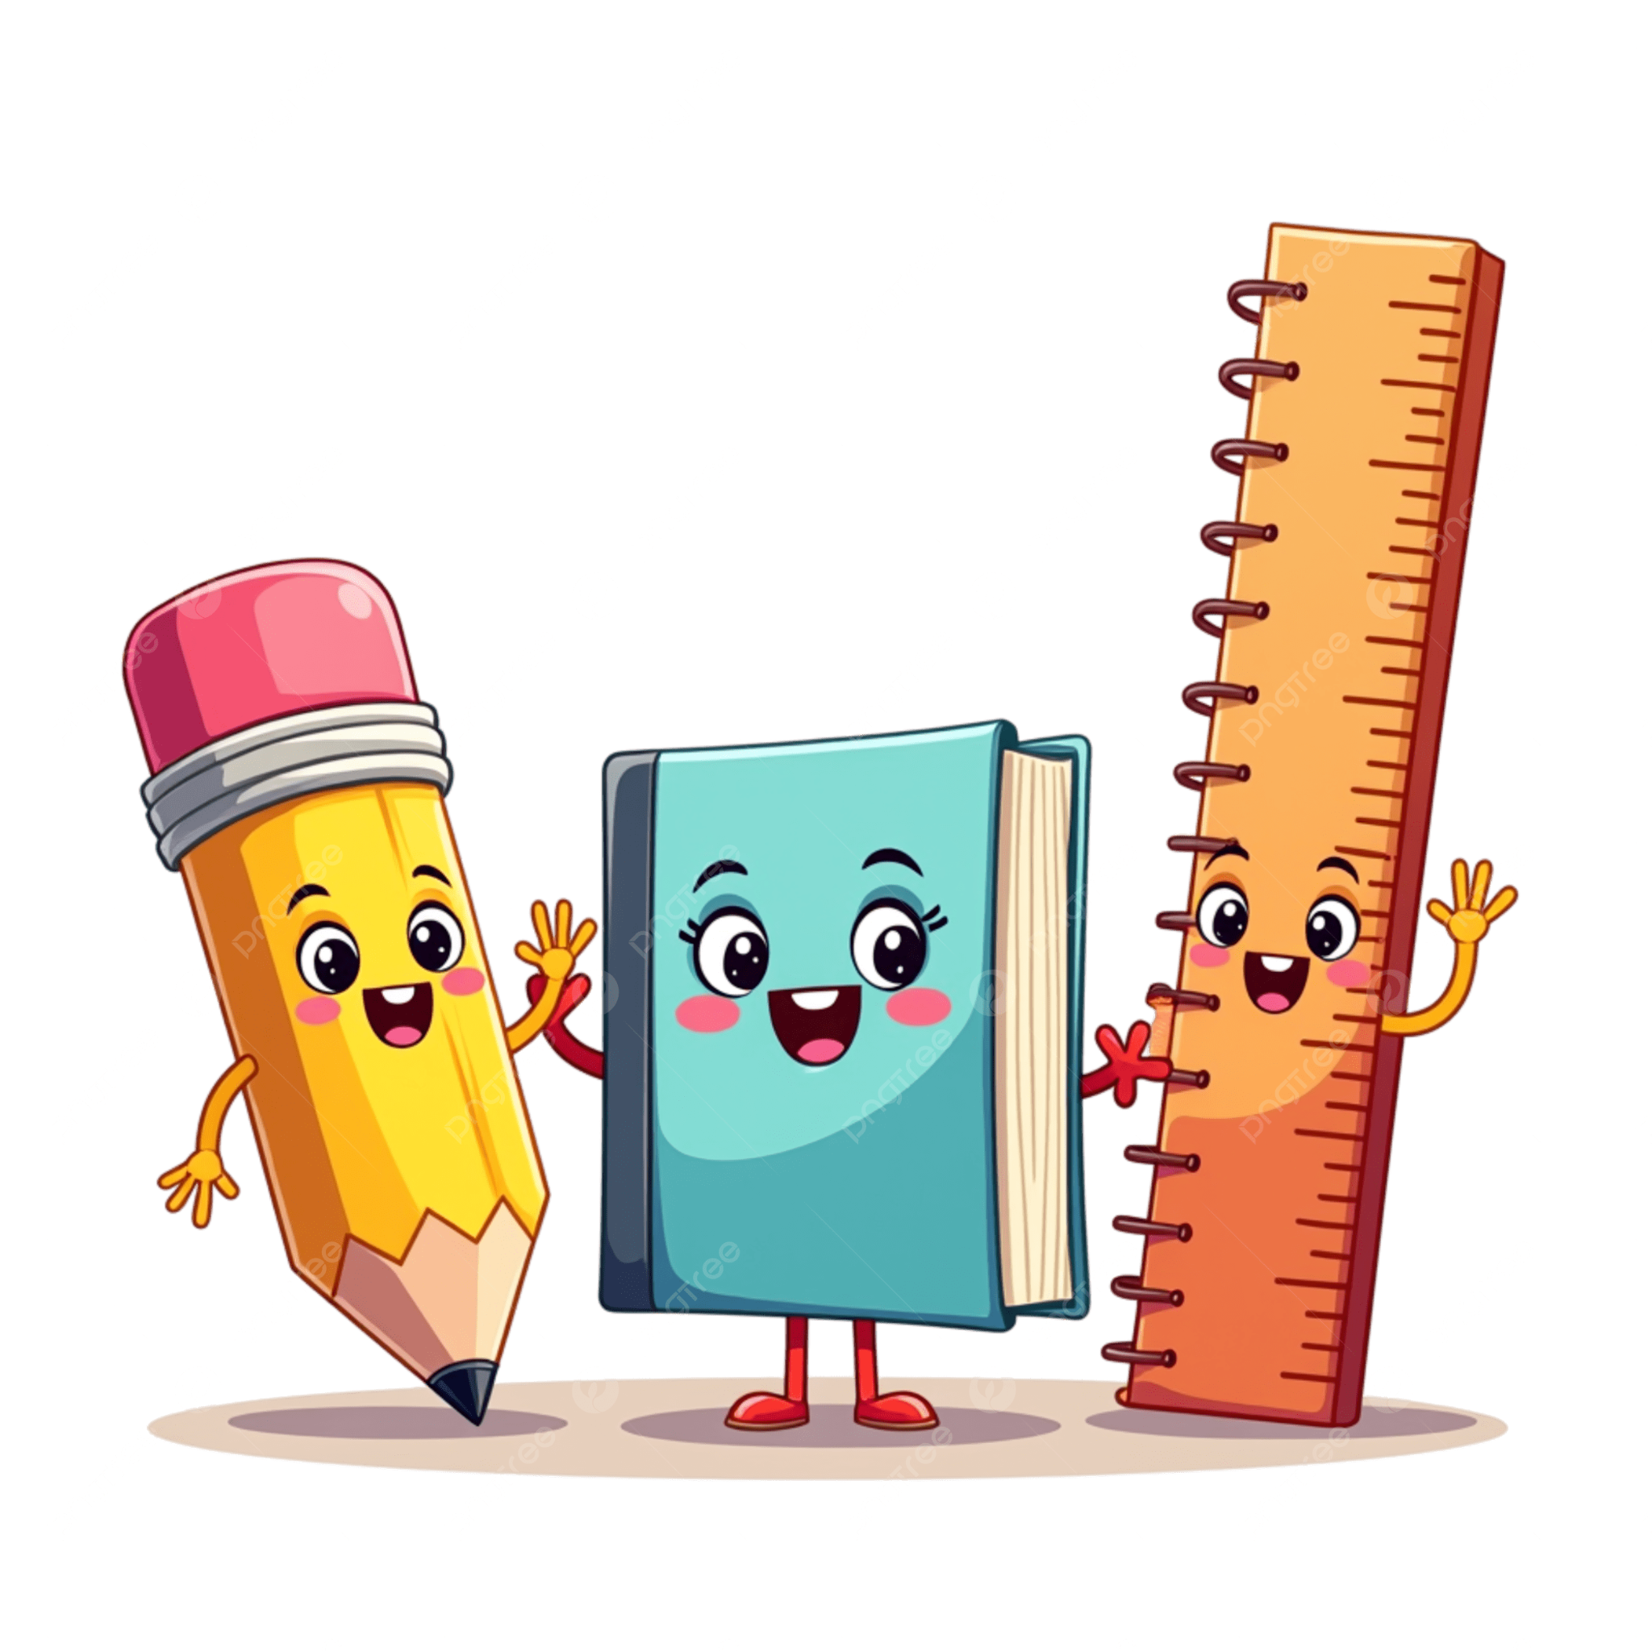
4K Supply List for 2026-27
- 1 LARGE (NOT JUMBO) pack of Crayola Crayons (8 count)
- 1 pack of Crayola Colored Pencils (24 count - non erasable)
- 4 boxes of Kleenex Tissues
- 1 pack of “Crayola Clicks” 10 count Markers
- (1) 3-pack ELMER’S Jumbo glue sticks (purple glue please) or 1 white liquid glue
- 1 Box of Ziploc Bags (Gallon)
- 2 Paper Towels (absorbant)
- 4 Containers of Lysol Wipes
- 3 reams of copy paper
- 1-2 reams of Astrobright Cardstock (assorted colors)
- 1 pack of baby wipes
- Playdough (4-6 pack)
- 1 Bottle of Hand Sanitizer
- 1 Large t-shirt for an art smock
- Nap Mat (sheet mat with attached top sheet)
- Backpack (no wheels) Should be large enough to fit a standard sized folder, lunch box, and a sweatshirt inside, yet small enough for your child to carry.
- Water Bottle - Approximately 12 ounces and made for a child. This will be brought to and from school everyday.
Please ONLY write your child’s name on his or her Backpack, Nap Mat, Lunch Box, Water Bottle, and Sweatshirt. All other items will be shared and do not need to be labeled. It’s going to be a GREAT year in the “Little Saints” classroom!

